University of Rwanda
College Of Science and Technology School of ICT
Computer and Software Engineering Department
GIKONDO CAMPUS
Reg No: 225059498
Year 1 Computer Engineering
Title: WEB DESIGN

PROJECT TECHNICAL REPORT
Project title: SMART PERSONAL FINANCE MANAGEMENT SYSTEM
Chapter 1: Introduction
  - Historical Background of the Case Study
When I first joined the University of Rwanda, I suddenly found myself with more money than I had ever managed before. I had savings from my holiday job, along with my first two months' living allowance from my sponsor. Moving to Kigali for the first time was exciting—I explored the city, traveled, bought things I thought I needed, and enjoyed my new independence.
A few months later, I realized all my money was gone. The most surprising part was that I couldn't clearly explain where it had gone. That experience taught me that earning money is one thing, but managing it wisely is another.
That moment inspired me to create the Smart Personal Finance System—a system that helps people track their income, expenses, loans, and debts, giving them a clear picture of their finances and helping them make smarter financial decisions before it's too late.
1.2. Problem Statement
Many individuals, particularly students, young professionals, and small business owners, struggle with managing their personal finances effectively. The challenges include:
- Lack of proper tracking: Without a dedicated system, people find it difficult to track their income and expenses systematically.
- Poor financial planning: Many individuals do not set financial goals or create budgets, leading to overspending and financial stress.
- Debt mismanagement: Without proper records of loans taken and money owed by others, individuals often find themselves in debt traps.
- No clear financial visibility: People lack a consolidated view of their financial status, making it hard to make informed decisions.
- Time-consuming manual methods: Traditional methods of financial tracking are labor-intensive and error-prone.
- Limited financial literacy: Many users need guidance on how to manage their finances better.
- No integrated platform: Existing solutions either are too complex, require technical expertise, or do not address all aspects of personal finance in one place.
Smart Finance aims to solve these problems by providing a user-friendly, comprehensive web-based platform for personal financial management.
1.3 Project Objectives
The main objective of this project is to design and develop a web-based personal finance management system that enables users to effectively manage their finances.
Specifically, the system allows users to record and track income, expenses, savings, loans, and debts; provides an interactive dashboard with financial reports and spending analysis; supports budget planning and financial goal tracking; includes subscription plans and user profile management; offers a responsive design with dark and light themes for a better user experience; and is structured to support future backend and database integration.
1.4. Expected Outcomes
- A fully functional web-based personal finance management application.
- Easy tracking of income, expenses, savings, loans, and debts.
- Financial insights through dashboards, reports, charts, and graphs.
- Budget planning and financial goal tracking features.
- Responsive, user-friendly interface with dark and light themes.
- Well-structured, maintainable system ready for future backend integration and deployment.
- Complete documentation for users and future developers.
1.5. Project Rationale
- Helps individuals manage their finances more effectively and reduce financial stress.
- Encourages budgeting, saving, and responsible financial habits.
- Assists students in managing limited budgets and learning financial planning.
- Supports young professionals in managing income, savings, and debts.
- Enables small business owners to track finances and make informed decisions.
- Promotes financial literacy, responsible money management, and digital financial inclusion within the community.

Chapter 2: System Design and architecture
2.1.1. Intended Users of the Project
The Smart Finance system is designed for a wide range of users, including:
- General users who want to manage their personal finances.
- Students who need help budgeting and tracking expenses.
- Young professionals managing income, savings, and debts.
- Small business owners monitoring business income, expenses, and financial reports.
- Freelancers handling irregular income and expenses.
- Household managers planning family budgets and savings.
2.1.2. Intended System Partners
The system is designed to support future collaboration with:
- Financial institutions for banking and loan integration.
- Mobile money services for payment processing and transaction synchronization.
- Educational institutions to promote financial literacy among students.
- Government agencies to support financial inclusion initiatives.
- Technology partners for cloud hosting and system infrastructure.
- Training organizations to provide financial education and user support.

2.2.1. High-Level Architecture
The Smart Finance system follows a modular architecture with the following components:

Chapter 3: Implementation
  - Landing page
This is index page/ Landing page, where user reach at first visit, he/she can see system description, and can navigate to main system by creating account, or by login in, if he/she is returning user
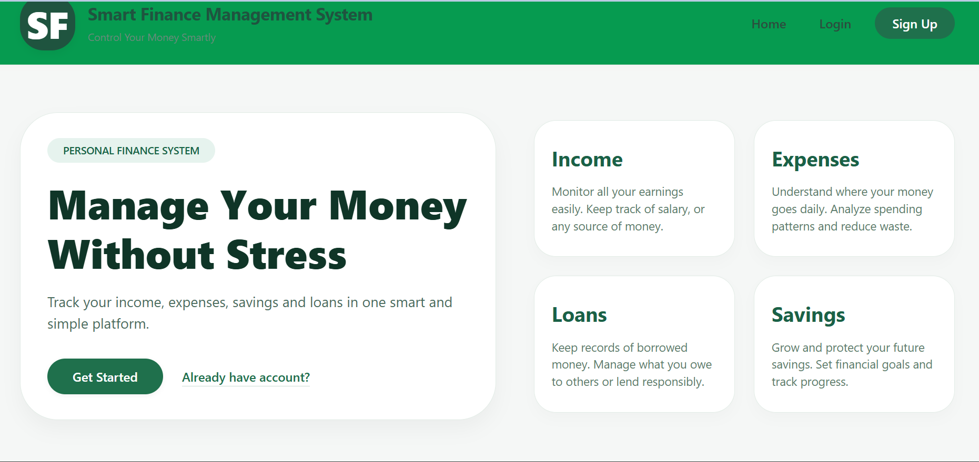
- Login and Signup pages
This page allows user to create accounts and login to their own account. It is simple and responsive.

  - Dashboard
This is main dashboard where users can access the system and can utilize all functionality in the system, he/she can record his/her transaction using the link at the aside of page. This dashboard is also responsive, even mobile phone user can use is very well. It fit in each and every devices.
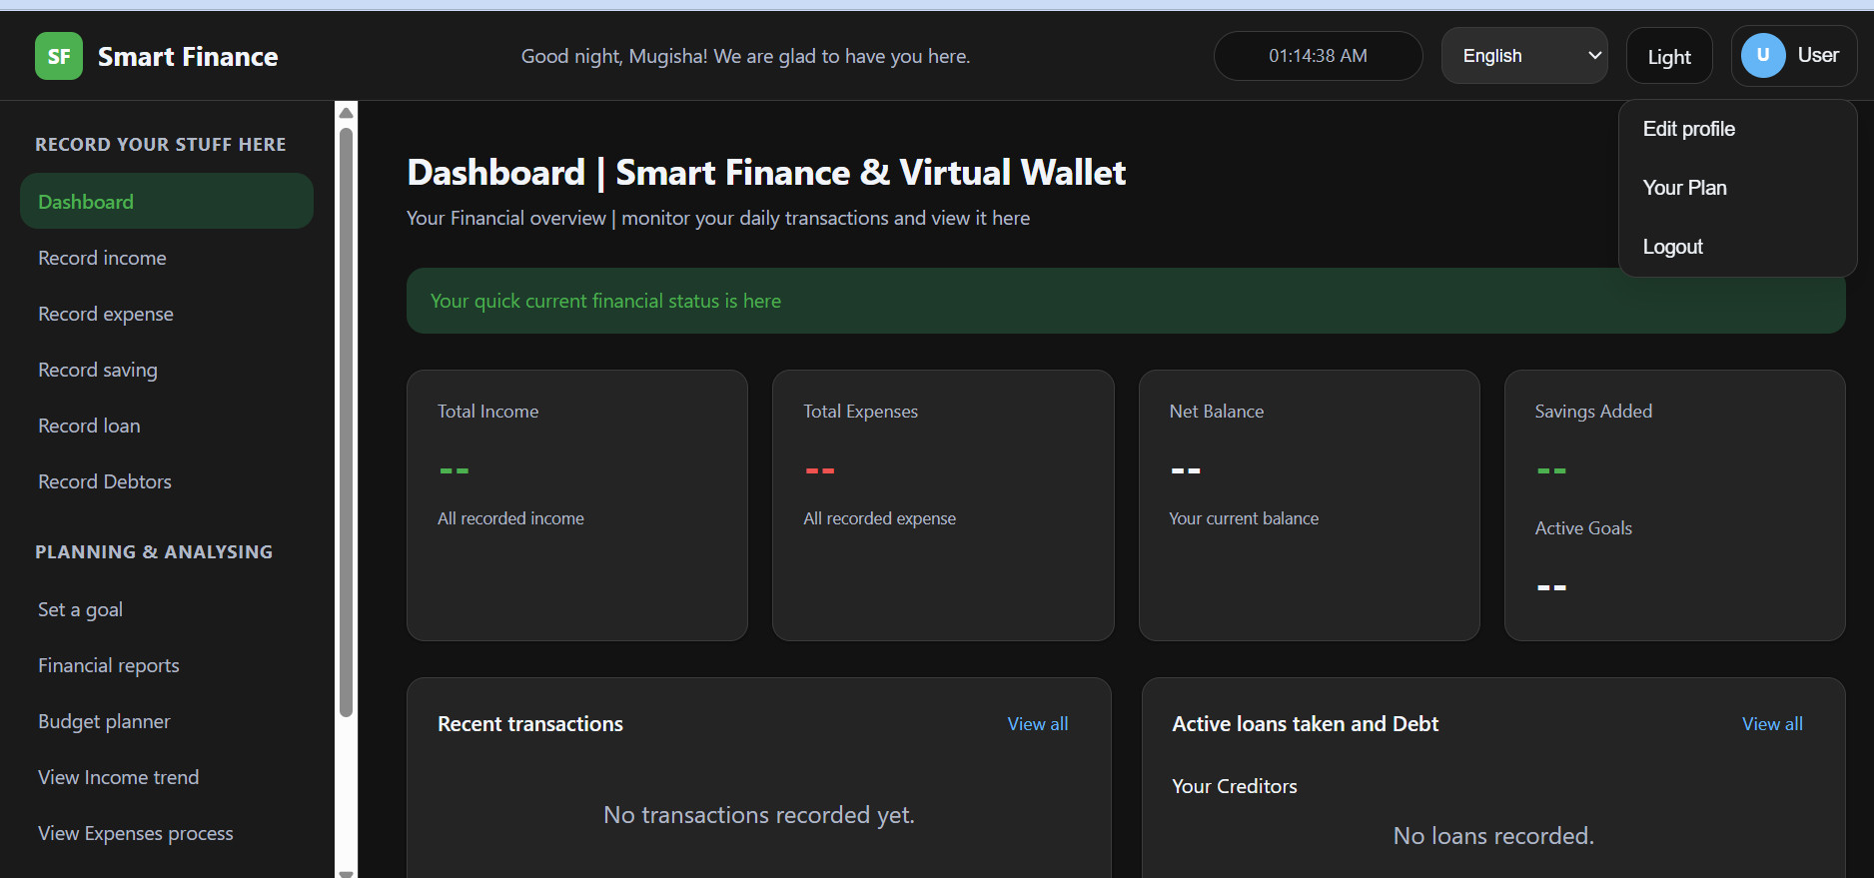

Chapter 4: Conclusion and Recommendation
4.1. State of the Implemented System
The Smart Finance web application has been successfully implemented as a comprehensive personal finance management system. The project has achieved approximately 60% of the stated objectives, with the following key accomplishments:

- Landing page: completed 100%
- Login and signup functionality : Design only, 50%
- Dashboard:
  - Income and expenses recording form: No validation of data
  - Loan and Debtors recording form
  - Saving and Goals recording Form
  - Financial Insights
  - Transaction List page
  - Budget planner page
- Setting page
  - Profile management :
  - User plan Link
  - Logout

Appendix:
Email: eliseusmugisha@gmail.com
Repository: https://github.com/mugisha-cyber/smart-finance
Password: MUGISHa@3030

